**Lab 3: USB_Image_Acquisition**

**What You Need for this lab**

* + Install Virtualbox : <https://www.virtualbox.org/wiki/Downloads>
  + Install Kali 2021.4. : <https://old.kali.org/kali-images/kali-2021.4/>
    - Notes: Suggest You configure the disk size of Kali VM 80G because the size of each leakage cases image is 30G+
* FTK Imager for windows

<https://accessdata.com/product-download/ftk-imager-version-4-5>

* A flash drive
* The dd utility:

<http://www.chrysocome.net/downloads/dd-0.5.zip>

**Step 1.**

* Download and install FTK

**Step 2.**

* Plug in a Flash Drive to your computer : you can copy come files to the USB.
* Verify your PC can read the USB drive

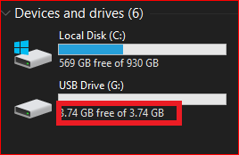

**Step 3.**

* Acquiring a USB using FTK

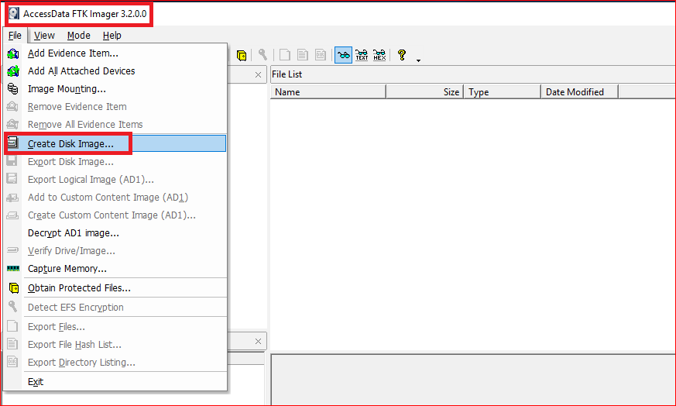

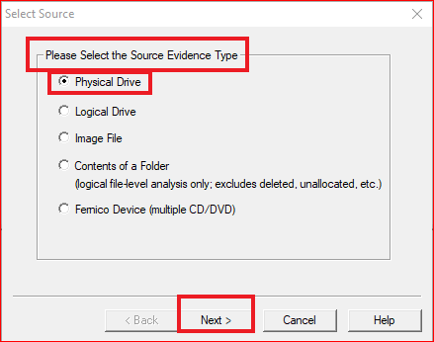

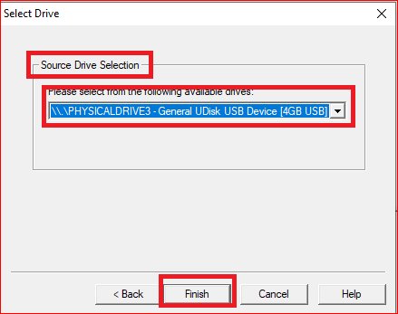

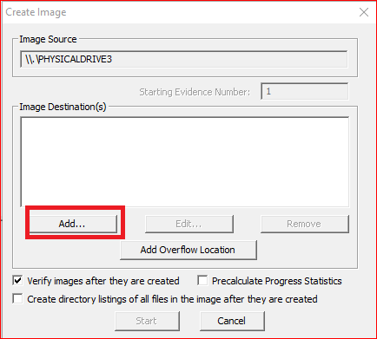

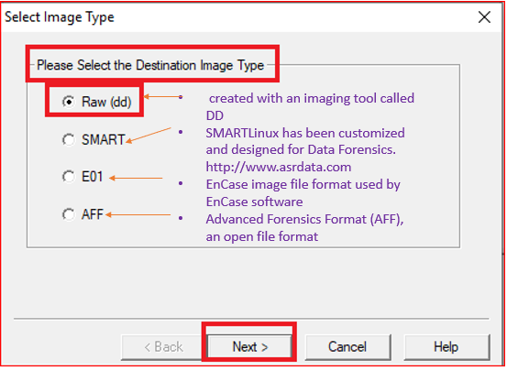

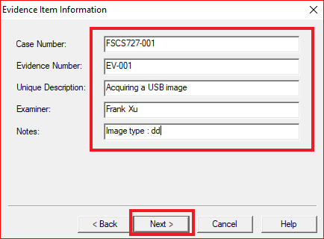

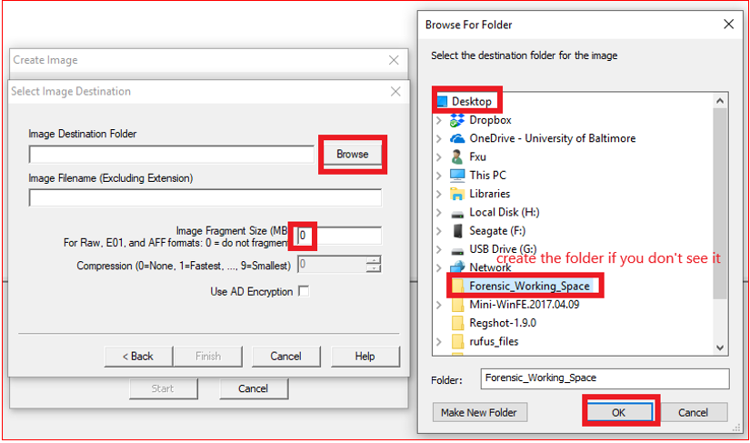

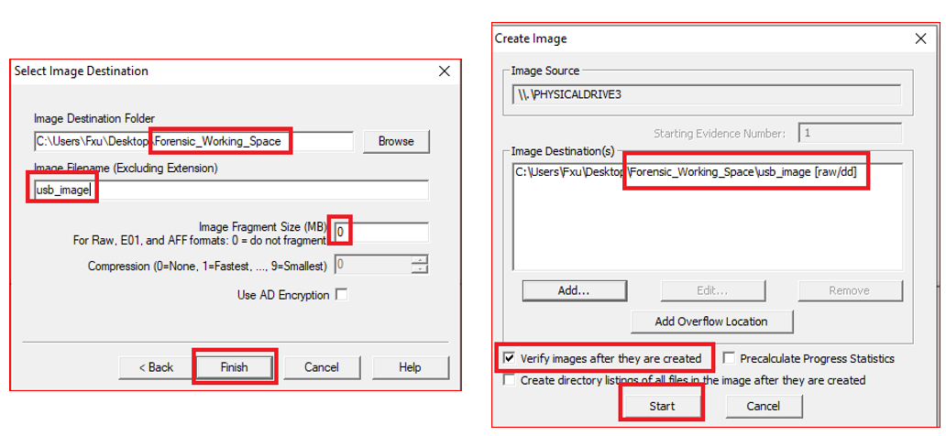

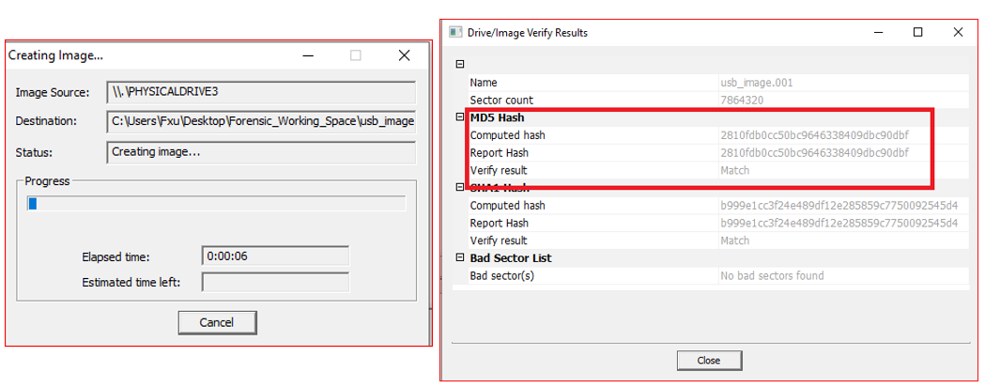

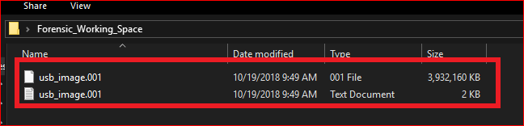

* Unzip dd utility and make a copy on your Desktop
* Check disks
  + *dd --list*
* Acquire the disk image
  + *dd if=\\.\Volume{6d634efd-0000-0000-0000-501f00000000} of=c:\usb.img*

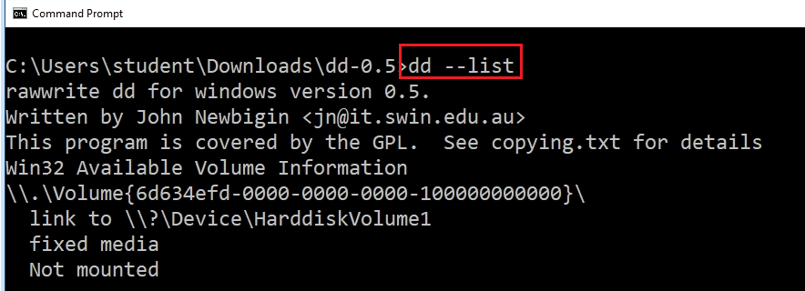

**YOU MUST SUBMIT A FULL-SCREEN IMAGE FOR FULL CREDIT!**

Save the document with the filename "**YOUR NAME Lab 3.pdf**", replacing "YOUR NAME" with your real name.

Email the image to the instructor as an attachment to an e-mail message. Send it to: **xxx@fe.edu.vn** with a subject line of "**Lab 3 From YOUR NAME**", replacing "YOUR NAME" with your real name.